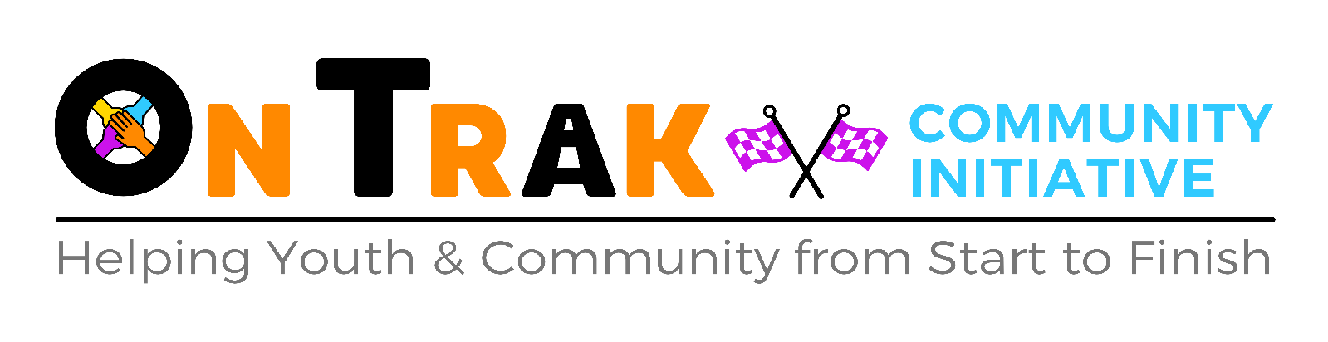
New Student Registration Pack 2023-2024
Please note that all the boxes must be filled in and all of the paperwork (Registration forms, EHCP’s etc and the SLA if a new setting) received BEFORE the student can start their placement with OnTrak. If the box is asking irrelevant information for your student, please put N/A. Please note without all of the requested information, we cannot offer your child/young person a placement at OnTrak. This referral will also be reviewed in-line with OnTrak’s policies.
Student Personal Details
Name
Preferred Name
D.O.B |  |  | Gender
Is this student a LAC? |  | Y / N
Primary Home Contact Name (Parent or Carer)
Address

Numbers

Email

Relationship to Young Person
Secondary Contact Name
Address

Numbers

Email

Relationship to Young Person
Travel – How will student get to OnTrak? |  | Own Arrangements / Taxi / Bus / Bike  Other:  Please note if by taxi or own arrangements, please ensure they arrive for pick up promptly at 3pm to avoid staff having to wait with the student after their finishing time.
Referring School / Care Home / Department and Address
Main School / Care Home Contact Numbers
Email
UPN
FSM / PP | Y / N – if Yes, details
Are any other agencies involved with this student and this referral? | Y / N – If Yes, which agency?  Social Services CAHMS Other:  Primary Contacts Name and Contact Email / Number:
Reason for the referral to OnTrak

Student Needs
Does this student have an EHCP, CIN or Statement?  Can you give a basic outline of any learning difficulties or SEND that this student has?  e.g. Diagnosis of: MLD, Dyslexia (statemented), ASD, SEBD, ADHD etc | Y / N - If Yes, we will need a copy of it before the placement starts.
Does this student have any behavioural issues?  What happens when this student experiences these issues? | Y / N – If Yes, give details.
Does this student have a medical or suspected medical diagnosis?  Any allergies or intolerances?  Does the student require any regular medication to take during the day? | Y / N - If Yes, give details.  Y / N – if Yes, give details and the Administration of Medication plan will need to be consulted and filled in where necessary.
Will this student require any additional support to take any exams or tests? | Y / N – If Yes, give details.

Other Settings
Has this student attended any other settings before attending OnTrak?  Why did they leave? | Y / N – If Yes, give details
% Attendance at previous settings
Any exclusions or suspensions?

Please identify the days for requested provision  Will they require English / Maths sessions? | MON TUES WEDS THURS FRI  AM  PM  Y / N – If Yes, please fill in the English and Maths information, if No, please read through the rest of the document and then sign.

English and Maths
English  Education Levels of YP:  - As Expected  - Below Expected  - Above Expected  Is there a teacher’s assessment to include? | Baseline Level:  Qualification Aim: Functional / GCSE  Exam Board Used:  Texts currently / recently studying:  Poems group chosen:  Resources requested: Y / N  Any other information:  Y / N – If Yes please include with this pack.
Maths  Education Levels of YP:  - As Expected  - Below Expected  - Above Expected  Is there a teacher’s assessment to include? | Baseline Level:  Qualification Aim: Functional / GCSE  Exam Board Used:  Resources requested: Y / N  Any other information:  Y / N – If Yes please include with this pack.

Examinations
OnTrak is an approved centre for NOCN Motor Maintenance certificates. OnTrak is available as an external venue for examinations which might suit some students – to book please contact us. If your student requires other examinations or support for examinations, please talk to us about their needs.

By signing this document, you are agreeing that the information that you have provided is both full and accurate. It is extremely important that we have the fullest picture of this student so that we can best prepare for them and best provide their education and support programme. Furthermore, by signing this document you acknowledge that the parents / carers consent to this referral. Should the school have deliberately withheld any information, then we may have to take legal advice. Should any information change, it is the school’s duty to inform OnTrak of these changes immediately.

Signed:_______________________________ Print Name:___________________________________

Position:____________________________________________

Date:_______________________________________________

Please fill in the financial information sheet within this pack and also sign the consent forms. Without this we cannot process the student’s information and this may result in a delay or refusal to offer a placement.

Student Off-Site and Photograph Consent Form

Please note that this form must be signed before your student can start at On Trak. As part of the registration, you will be given a copy of our most recent risk assessments and policies.
By signing this document, I can confirm that I have the due authority to sign and give consent to the student being taken off site to continue their learning journey with OnTrak (this includes residentials such as camping trips, attending events, going on bike runs and deliveries) and that the information provided on this form is true, complete and accurate. I agree to notify On Trak immediately of any changes or updates in information with regards to this student.
We take pictures internally for the student files and module work. Occasionally we may use these pictures for show casing our charity and student work at external events like motor shows and colleges but without any student details. Please tick if you DO NOT want this student’s pictures used in this capacity.

Signed__________________________________________

Print Name_______________________________________

Date___________________

Within two weeks of the student starting their placement, a member of the school team responsible for this student must come to On Trak to view the facilities, staff and, if it is after the student has started, the student working within their placement. Please tick one of the following:
- I need to book a date/time to attend On Trak

- I have attended before with another student and am happy for the student to proceed with their placement.

Financial Information for Accounts

Name of Student
School and Address
School Contact Name and Number

Accounts and Finance Department Contact Name, Number and Email

Purchase Order Number if needed
Contact Method | Email invoice  Is the email / contact above the one to email the invoice to?  Y / N

Invoices will be issued at the end of each month or term and will be expected to be paid within 14-28 days. If there are any issues, follow the contact details on the invoice to discuss.

