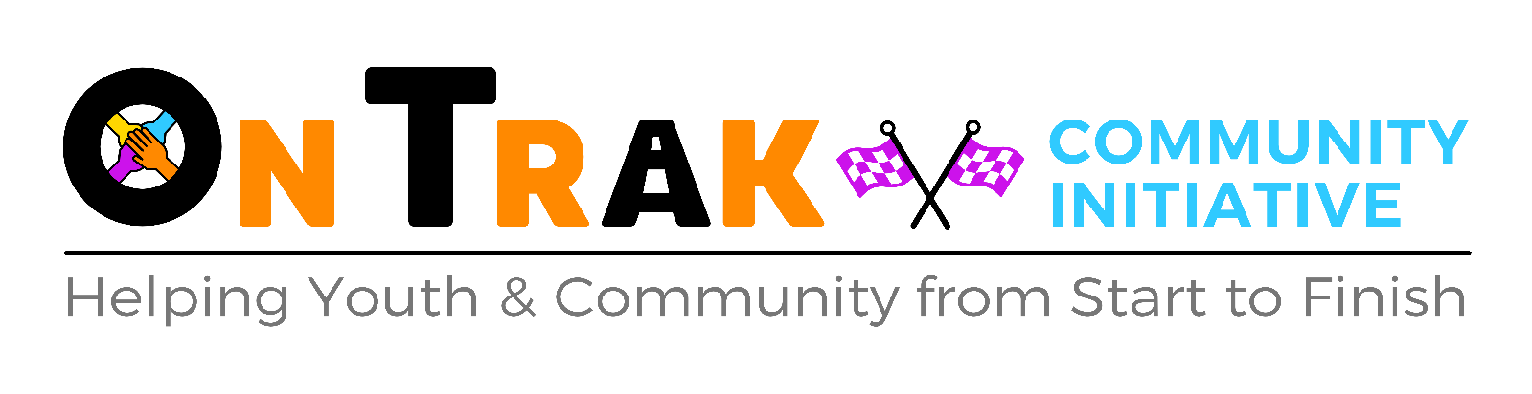

SERVICE LEVEL AGREEMENT
BETWEEN ONTRAK COMMUNITY INITITIATIVE and
______________________________

- Parties to the agreement
This partnership Memorandum of Agreement is made on __________20__ between ONTRAK and _______________________________.
Registered addresses of the organisation and partnership organisation:
OnTrak Community Initiative  St Enoch’s Road  Wibsey  Bradford  BD6 3BU | Organisation Address

- Terms and Conditions
The terms and conditions of the partnership agreement are:

2.1 The partnership between OnTrak and __________________________________exists solely to successfully deliver the OnTrak educational programme.
2.2 The programme duration will be from ____________20___ to ongoing.

2.3 The partners to this agreement agree to respect confidentiality on formal matters relating to each other. In cases of a Safeguarding concern the necessary Disclosure process will be followed. Progress and performance is a legitimate area for discussion and for reporting in summary terms to each of the partners’ boards.

- Purpose of the agreement and summary of project
This agreement exists to deliver the OnTrak Educational Programme. The working day is 9am until 3pm. Students must arrive promptly and be ready with their working PPE gear on (doors open from 8.30am).
- Roles and Responsibilities
  - OnTrak will provide a location in its premises and at Tockwith Motor Sports Centre to hold sessions and workshops as part of the OnTrak Education Programme.
These locations will provide and fulfil requirements for safe interactions and learning, and for parents/carers/staff to hold reviews/meetings/observations.
4.2 OnTrak will work with the school/organisation to ensure adequate provisions are in place during the delivery of the OnTrak Education Programme and abide by _______________________ safeguarding policies should they be different to OnTrak’s and include any specific requirements for students.
4.3 Prior to the delivery of programme the start date and end date, a timetable, student placement needs analysis and schedule of sessions will be agreed by both parties.
4.4 ________________________ will allocate a member of staff to be a first point of contact (SPOC) to OnTrak for the duration of the programme. A second point of contact will also be assigned in the instance the first contact is absent from the school. These contacts are _____________________________________ and ____________________________________
4.5 The identified SPOC will regularly communicate with OnTrak about students placements, progress and QA for the duration of the OnTrak Education Programme.
4.6 A copy of OnTrak’s risk assessments, policies and any other documents will be sent to the organisation prior to the start of the OnTrak Education Programme and will be available on the website for download.
4.7 A member of staff from __________________________________who is in charge of safeguarding will be identified prior to the start date of the OnTrak Education Programme. That contact is ______________________________________.

- Communication and Project Development
5.1 The main communication relating to the project will take place between OnTrak’s Natalie Kershaw and Adrian Woods and the identified SPOC at regular meetings either face to face, online, email or via telephone.
5.2 OnTrak will communicate directly with the first point of contact throughout the duration of the OnTrak Education Programme delivery. This will include any queries relating to the service, reports and other incidents arising.
5.3 OnTrak will be responsible for generating reports about student progress throughout the OnTrak Education Programme at regular intervals. Any other matters arising will be queried/communicated through the first point of contact.
5.4 Co-operation from the organisation and the SPOC around this reporting and the expedient handling of any queries will be prevalent in the successful delivery of the OnTrak Education Programme.
- Costs 2023-2024
The cost of delivering the OnTrak Education Programme is £90/day, £28/hour English and Maths (or £14/session) and £3/lunch. This amount will be paid within 14-28 days of receiving the invoice to the following account:

Name of Bank: Lloyds Bank, Commercial Street, Halifax, HX1
Sort code: 77-71-30
Account Number: 44410468

Reference will be on the invoice. The finance contact will be __________________________________________________________________________[email / name]
Should a student be absent but OnTrak has staffing and resources in place, the organisation will still be charged. If a student leaves before the agreed date, the organisation may be charged up to 2 weeks (or up to the end of the month). We MUST have written confirmation that the student has left their placement. We do have waiting lists and without written confirmation, OnTrak will assume that the placement is being held for that student and will charge accordingly.
- Timescale
The duration of this partnership agreement is equal to the duration of the OnTrak Education Programme running from agreed placement start date until the agreed end.
Should this timescale change due to any matters arising, this will be discussed/reported to the first point of contact. A review of the student’s placement and needs will take place.

- Outputs
The following outputs have been agreed as part of the OnTrak Education Programme
- Regular termly reports and updates
- Education programmes designed to enhance healthier attitudes towards progression

- Declaration
Signed by, and on behalf of OnTrak by:

Name: Signature: Date from:
Adrian Woods MBE Adrian Woods 1st September 2023

Signed by, and on behalf of ____________________________________________:

Name: Signature: Date:

___________________________________________________________________________

