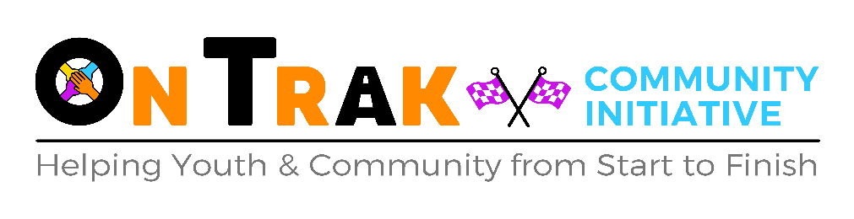

Volunteer and Work Placement Policy

1. Introduction
OnTrak Community Initiative aims to:

- Create a safe and friendly learning environment for all our students, staff and volunteers
- Develop and grow our students’ experiences and characters
- Create positive opportunities and pathways for next steps.

Our volunteers (henceforth “volunteers” shall also include those on work placement) make a vital contribution to our aims. We recognise the added value that volunteers bring to our organisation and those who use our services. Volunteer involvement in this organisation does not replace or devalue the role of paid staff.

OnTrak Community Initiative aims to have a reciprocal and mutually beneficial relationship with our volunteers; with their involvement informing and developing our work, and our work enabling individuals to learn skills and achieve personal development through their volunteering.

The involvement of volunteers will be guided by the following principles of good practice:
- the tasks to be performed by volunteers will be clearly defined, so that all everyone is sure of their respective roles and responsibilities;
- the organisation will comply with GDPR UK in the use of data held on all volunteers;
- volunteering opportunities will complement rather than replace the work of paid staff
- volunteers will be provided with regular opportunities to share ideas/concerns with a named contact in line with our Support and Supervision Policy;
- all existing and future policies will be checked as to how they affect volunteers

2. The Purpose of this Policy

By adopting this policy OnTrak Community Initiative aims to:
- highlight and acknowledge the value of the contribution made by volunteers;
- reflect the purpose, values, standards and strategies of the organisation in its approach to involving volunteers;
- recognise the respective roles, rights and responsibilities of volunteers;
- confirm this organisation’s commitment to involving volunteers in its work;
- establish clear principles for the involvement of volunteers; and
- ensure the ongoing quality of both the volunteering opportunities on offer and the work carried out by our volunteers;

This policy provides an overview of the activities carried out by volunteers currently and provides a basis for the expansion, if required, for the role of volunteers alongside paid staff. This document and the associated policy, procedures and guidance provide a framework for the involvement of volunteers.

3. Recruitment and Selection
OnTrak Community Initiative will adhere to its equalities and diversity policy when recruiting and selecting volunteers. All potential volunteers will be asked to complete a volunteer’s application/registration form. Written task descriptions will outline time, commitment, necessary skills and actual duties. Where there is specific training required this will be highlighted as part of the recruitment process. Where there is a requirement for a Disclosure Check this will be highlighted as part of the recruitment process. All volunteers will be required to provide 2 references.

Support and Supervision
Once placed, we will expect volunteers to comply with existing policies and procedures. All volunteers are covered under OnTrak Community Initiative’s Public Liability Insurance.

All volunteers will have an induction to their volunteering which will involve an overview of the relevant policies and procedures. Following Induction, volunteers will have regular support and supervision meetings with a named contact to identify areas for development, or to discuss any issues. A record of these discussions will be held as part of the individual volunteer’s records. Volunteers can have access to their records at any time.

Volunteers should discuss any planned expenditure prior to incurring this expenses to ensure that it will be covered by the organisation.

Where volunteers have holidays or other commitments which mean that they cannot attend their normal volunteering, they should advise their named contact to ensure that we can arrange alternative cover. If volunteers require a longer break from their volunteering, they should discuss this with their named contact. OnTrak Community Initiative will endeavour to be as flexible as possible to accommodate the needs of volunteers.

Volunteers can access learning and development opportunities which are relevant to their volunteering role throughout their time with OnTrak Community Initiative. Opportunities for Learning and Development will form part of the discussions at support and supervision sessions.

Problem Solving
Where a concern is highlighted – either by a volunteer or about a volunteer, this will be dealt with using the organisation’s Disciplinary, Grievance and Dismissal Policy.

Responsibility
Overall responsibility for the implementations, monitoring and review of the policy and procedures lies with Adrian Woods. Implementation and adherence to this policy is the responsibility of all staff and volunteers within the organisation.

1st September 2023
[Date for Review – 31st August 2024]

The volunteer

I, ……………………….………………………………………………………………………..(full name), agree to be a volunteer with OnTrak Community Initiative and commit to the following:
- To help OnTrak Community Initiative fulfil its aims and objectives.

- To perform my volunteering role to the best of my ability and behave appropriately around the young people, other volunteers, visitors and staff.

- To adhere to the organisation’s rules, procedures and standards, including health and safety procedures and its equal opportunities policy in relation to its staff, volunteers, students and clients.

- To undertake a DBS

- To read and sign the most up to date KCSIE and if necessary undertake safeguarding training

- To maintain the confidential information of the organisation and of its clients and students.

- To meet the time commitments and standards undertaken, other than in exceptional circumstances, and provide reasonable notice so that alternative arrangement can be made.

- To provide referees, as agreed, who may be contacted, and to agree to a police check being carried out where necessary.

- Please note that this is a non-smoking building so if the volunteer does smoke, they will be required to leave the building to do so.

My agreed voluntary time commitment is …………………………………………………………………….
Volunteer role ..………………………………………………………………………………
Volunteer Mobile ………………………………………………………………………….…
Volunteer Email …………………………………………………………………………………

This agreement is binding in honour only, is not intended to be legally binding contract between us and may be cancelled at any time at the discretion of either party. Neither of us intends any employment relationship to be created either now or at any time in the future.

Volunteer Signature………………………………………………………………………………..

Signed…………………………………………………………………………………..on behalf of OnTrak Community Initiative
Date:
Volunteer Tasks

The volunteer will ensure that they adhere to the organisations rules and regulations including wearing appropriate PPE equipment, not using phones except during break and lunchtimes and assisting where possible with all tasks. Tasks and routine will include:
Time | Task
Between 8am – 9am | The volunteer will assist with the preparation and cleaning of the workshop, classroom or other work areas as directed as soon as they arrive. This will ensure a smooth and organised running of the day.
9am – 10.30am | Tasks to be undertaken as directed.
10.30am-11am | The volunteer will take their breaks at the same time as the young people.
11am – 12.30pm | Tasks to be undertaken as directed.
12.30pm – 1pm | Lunchtime
1pm – 2pm | Tasks to be undertaken as directed.
2pm – 2.30pm | The volunteer will take their breaks at the same time as the young people.
2.30pm – 3pm | Tasks to be undertaken as directed and then home time at 3pm!

